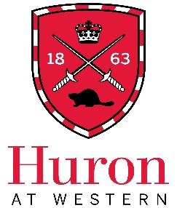
Job Title: CURL Student Web/Media Assistant

Expected Start Date: October 10, 2023
End Date: April 30, 2024
Direct Supervisor: Sherri Liska, Access and Media Coordinator, CURL
Hours per Week: ~7-10
Rate of pay: $16.55 per hour

Job Overview
The Centre for Undergraduate Research Learning (CURL) is seeking a part-time student assistant to provide creative support with CURL’s social media and online presence, especially during conference season (November-December and March-April). Duties would include writing, designing, and scheduling social media posts; updating our Wordpress website; and other online tasks as required. This is a remote/online position.

Preferred Qualifications
- Strong writing and proofreading skills
- Strong eye for design (positive/negative space, use of colour, clarity, etc.)
- Experience with graphic/web design (especially Canva/Wordpress), social media content creation, and/or journalism would be a strong asset
- Personable and courteous in working relationships with faculty, peers and the public
- Enthusiastic about undergraduate research learning, diversity, and accessibility
- Ability to organize time, communicate barriers, and ask for help when needed

Eligibility
- All undergraduate students registered at Huron University College with a minimum 60% course load (40% course load for students with disabilities) are eligible.

Application
To apply, please forward a letter of interest, a resume, contact information for one academic and/or professional reference, and requests for accommodation during the interview process to sliska@uwo.ca AND curl@uwo.ca. Please put “CURL Web Assistant Application – [Your Name]” as the subject line.
Examples of previous writing, design, or social media content, whether personal, academic, or professional, are very strongly encouraged.

All applicants must complete a financial profile with Jane Parker (mjparker@huron.uwo.ca). Students who are ineligible for a Huron work study ARE still eligible for this role.

Applications are due by 11:59PM on Sunday, September 17, 2023.
Zoom interviews are expected to occur the week of September 25-29.

