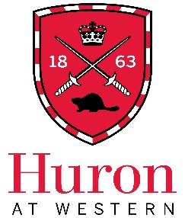

Job Title: CURL Student Ambassador

Expected Start Date: October 10, 2023
End Date: April 30, 2024
Direct Supervisor: Dr. Mike Kottelenberg, Economics
Hours per Week: 5-7
Rate of pay: $16.55 per hour

Job Overview
The Centre for Undergraduate Research Learning (CURL) is seeking a part-time Student Ambassador, in partnership with our current Senior Ambassador, to support CURL in planning events and connecting to the Huron student community. Duties include visiting classrooms to share information about CURL, proposing co-facilitating CURL events, gathering student feedback, recruiting student volunteers, and providing assistance with various tasks during CURL conferences (the Fall Exhibition on Friday, December 9 and the Spring Conference in early April, date TBD.)

Preferred Qualifications
- Enthusiastic about undergraduate research and education
- Personable, confident, and courteous in working relationships with the Huron community
- Able to organize time, meet deadlines, and ask for help when needed
- Comfortable with both independent and team-based work
- Comfortable leading presentations both in-person and online
- Comfortable supporting CURL’s goals of equity, diversity, accessibility, and inclusion
- Experience planning events would be considered an asset
- Experience with social media content creation would be considered an asset

Eligibility
- All undergraduate students registered at Huron University College with a minimum 60% course load (40% course load for students with disabilities) are eligible.

Application
To apply, please forward a letter of interest, a resume, the contact information of one academic and/or professional reference, and any requests for accommodations during the interview process to curl@uwo.ca AND sliska@uwo.ca. Please put “CURL Ambassador Application – [Your Name]” as the subject line.

Applications are due by 11:59PM on Sunday, September 17, 2023.
Zoom interviews are expected to occur the week of September 25-29.

